

CS-9320-SERVICE ORITENTED ARCHITECUTRE:
CONCEPT & TECHNOLOGY

Supplier Management System

BY
Mg Zaw Ye Naung
5SE-THANATA-874

CAPSTONE PROJECT

SUBMITTED DATE 10 MARCH 2025

TABLE OF CONTENTS

Page
TABLE OF CONTENTS 2
ACKNOWLEDGEMENT 4
ABSTRACT 5

CHAPTER TITLE
1 INTRODUCTION
1.1. Introduction 6
1.2. Objectives of the System 6
1.3. Problem Statement 6
1.4. Requirements 7
1.4.1. Functional Requirements 7
1.4.2. Non-Functional Requirements 7

2 THEORETICAL BACKGROUNDS
2.1. Multi-Criteria Decision Making (MCDM) 9
2.2. Data Normalization Techniques 10
2.3. Weighted Scoring Algorithm (WSA) 11
2.4. Advantages of Weighted Scoring Algorithm 11
2.5. Limitations of Weighted Scoring Algorithm 12
2.6. Explicit Feedback and Implicit Feedback 12

3 PROJECT SPECIFICATION
3.1. Project Charter 13
3.2. Project Schedule 13
3.3. Steps Involved on the Journey to Construct the
Proposed System 14

4 DESIGN AND IMPLEMENTATION OF THE SYSTEM
4.1 System Design 16
4.2. Dataset Preparation Overview 17
4.3. Algorithm Implementation 18
4.3.1. Why Min-Max Normalization? 18
4.3.2. Applying Min-Max Normalization in WSA 19
4.4. System User Interface 19

5 TESTING
5.1. Test Case Specification 24
5.1.1. Supplier Submission Form Page Test 24
5.1.2. Supplier List Page Test 25
5.1.3. Analysis Page Test 25
5.1.4. Report Page 25

6 APPLICATION CONFIGURATION
6.1. Hardware Requirements 26
6.1.1. Development Environment Requirements 26
6.1.2. Server Deployment Requirements 26
6.1.3. Additional Hardware Requirements 27
6.2. Software Requirements 27
6.2.1. Development Environment Requirements 27
6.2.2. Server Deployment Requirements 28

7 CONCLUSION AND FUTHER EXTENSION
7.1. Conclusion 29
7.2. Limitation 29
7.3. Future Work 30

LIST OF FIGURES 31
LIST OF TABLES 32
REFERENCES 33

ACKNOWLEDGEMENT

I would like to express my sincere gratitude to everyone who supported me during the development and success of the Supplier Management System project. This project would not have been possible without the guidance and resources available to me throughout the process.
First of all, I am incredibly grateful to Dr. Saw Sanda Aye, the esteemed Rector of the University of Information Technology for her invaluable suggestions and encouragement.
I would like to express my gratitude thanks to Dr. Than Than New,Professor and Head of the Faculty of Information Science) for the leadership, kindly guidance, helps, and suggestions. I also would like to extend my heartfelt thanks to Dr. Aye Chan Mon, Associate Professor of the Faculty of Information Science) for her continuous support, knowledge, and encouragement throughout academic journey.
I also would like to thank my mentors and advisors for their invaluable feedback and encouragement. Their expertise in system design and supply chain management helped shape the direction of the project and ensured that it met industry standards. I am also grateful for the resources that provided the tools, libraries, and frameworks that were essential to building the system. Their contributions were key in helping me develop a high-quality and efficient solution.
Lastly, I would like to thank the businesses and professionals in the field of supplier management for inspiring and informing many of the design decisions in this system. Their real-world input played a significant role in shaping the features and functionality of the project. This project is the result of my efforts, but I am deeply appreciative of the support and resources that made it possible.

ABSTRACT

The Supplier Management System is a web-based application designed to streamline the process of supplier evaluation and management. The system aims to simplify the assessment of suppliers based on key factors such as product quality, supplier ratings, and price differences. By utilizing a weighted scoring algorithm, the system allows users to rank suppliers objectively, helping businesses make data-driven decisions when selecting suppliers. The system is capable of importing supplier data either through manual entry via forms or by uploading CSV files, making it flexible and easy to update with new information.
The system’s main features include a supplier submission form page, which allows users to input new supplier data, and a supplier list page, where all supplier details are displayed. Additionally, the analysis page includes bar charts and pie charts to visually represent the data, providing valuable insights into supplier performance. The ranking supplier page uses the weighted scoring algorithm to assess and rank suppliers based on normalized product quality, supplier rating, and price difference. The system is built using Java Spring Boot for the backend, PostgreSQL for data storage, and Thymeleaf with HTML, CSS, and JavaScript for the front end.
This project aims to enhance procurement decision-making by providing a user-friendly platform for managing supplier data and evaluating supplier performance based on multiple criteria. By offering detailed visual analytics and leveraging a transparent scoring mechanism, the system supports businesses in choosing the best suppliers while ensuring the most competitive pricing and highest quality products.

CHAPTER 1
INTRODUCTION

  - Introduction
The Supplier Management System (SMS) is a software solution designed to streamline and optimize the process of managing suppliers within a business environment. Managing suppliers is a critical aspect of procurement and vendor management in many industries. Traditionally, businesses handle supplier information in a fragmented and manual manner, which often leads to inefficiencies, errors, and lack of visibility. The purpose of the SMS is to automate the collection, management, and analysis of supplier data, allowing businesses to make more informed decisions.
This system is built using Java Spring Boot for the backend, which is a powerful framework for developing robust and scalable web applications. PostgreSQL is used as the database to store and retrieve data, providing a reliable and flexible platform for handling large volumes of supplier information. For the frontend, Thymeleaf is utilized for templating, while HTML, CSS, and JavaScript ensure a responsive and visually appealing user interface. The system is designed to facilitate the management of suppliers by providing tools such as data entry forms, visual analytics, and supplier ranking using a weighted scoring algorithm.

  - Objectives of the System
The primary objective of this system is-
- To facilitate Supplier Submission efficiently
- To enable viewing, updating and deleting of supplier information.
- To provide visual Analysis on the supplier data for better insights.
- To rank the suppliers by each category for decision making

  - Problem Statement
In the absence of a streamlined and automated supplier management system, businesses often rely on manual methods to assess and manage suppliers. This can lead to inefficiencies, mistakes, and subjective decision-making. For instance, procurement teams may find it challenging to compare suppliers objectively based on factors like price, quality, and service levels. Without proper analytics and visualization tools, it’s difficult to understand supplier performance over time.

The Supplier Management System aims to address these issues by providing a digital solution that automates the collection and analysis of supplier data. By incorporating a Weighted Scoring Model and visual tools, the system provides an objective and data-driven approach to supplier management, reducing reliance on intuition or guesswork.
  - Requirements
    - Functional Requirements
The system will offer a set of functionalities designed to enhance the user experience and meet the operational needs of the business. The key functional requirements include:
- Supplier Submission Form: A user-friendly interface where users can input data about new suppliers, including the supplier’s name, product category, quality, rating, contact information (email, phone, address), and pricing information (minimum and maximum price). This ensures that all supplier data is captured in a consistent format.
- Supplier List Page: A page that displays all the supplier data in a tabular format. This table allows users to filter, search, sort, and paginate through the list of suppliers. Each supplier entry will have options to view detailed information, update existing data, or delete the supplier entry if necessary.
- Analysis Page with Bar and Pie Charts: This page will provide visual analytics that summarize supplier data. Bar charts can be used to compare supplier ratings, while pie charts can provide insights into the distribution of product categories or price ranges among suppliers. The charts will be interactive, allowing users to drill down for more detailed information.
- Ranking Suppliers Using a Weighted Scoring Algorithm: The system will implement a weighted scoring algorithm to objectively rank suppliers. The algorithm will normalize and score key factors such as product quality, supplier rating, and price difference (calculated as the maximum price minus the minimum price). The suppliers will be ranked based on their total score, helping users identify the best suppliers for their needs.
    - Non-Functional Requirements
In addition to the functional requirements, there are several non-functional aspects that the system must adhere to in order to ensure quality, reliability, and scalability:
- Performance: The system should be able to handle large volumes of supplier data efficiently, without compromising speed or responsiveness. This is particularly important as the number of suppliers grows over time.
- Security: All sensitive data, such as supplier contact information and financial details, must be stored securely. This includes implementing encryption methods for data storage and secure transmission channels for data exchange.
- Usability: The user interface should be simple, intuitive, and responsive. Users should be able to navigate through the system easily without requiring extensive training.
- Scalability: The system should be able to scale seamlessly as the number of suppliers increases. This includes both the backend (such as database optimization) and the frontend (responsive design to accommodate varying screen sizes).

CHAPTER 2
THEORETICAL BACKGROUND

  - Multi-Criteria Decision Making (MCDM)
Multi-Criteria Decision Making (MCDM) is a set of methods or procedures used for comparing, ranking, and selecting from among alternatives that are characterized by multiple, usually conflicting, criteria. It helps decision-makers make more informed choices by considering various factors, not just a single objective.
Key elements of MCDM:
- Alternatives: These are the options or choices available to the decision-maker.
- Criteria: These are the attributes or factors that influence the decision. For example, in a project selection process, criteria could include cost, time, quality, and resource availability.
- Weights: These are the relative importance of each criterion. Weights can be assigned based on the significance of each factor to the decision.
- Ranking/Scoring: Alternatives are scored based on how well they perform against each criterion, and then ranked.
Methods of MCDM:
- Weighted Scoring Algorithm (WSA): A straightforward approach where each criterion is assigned a weight, and the performance of each alternative is rated on each criterion. The total score for each alternative is calculated by summing the weighted scores.
- Analytic Hierarchy Process (AHP): A structured technique for organizing and analyzing complex decisions. It involves pairwise comparisons of criteria and alternatives, followed by synthesizing results into a final decision.
- Technique for Order Preference by Similarity to Ideal Solution (TOPSIS): This method compares the alternatives to an ideal solution and a negative ideal solution. The alternative closest to the ideal and farthest from the negative ideal is considered the best choice.
- Elimination and Choice Expressing Reality (ELECTRE): A family of methods that compares alternatives and eliminates those that do not meet certain thresholds, allowing for the best alternatives to be chosen.
- Preference Ranking Organization Method for Enrichment Evaluations (PROMETHEE): Another method that ranks alternatives based on pairwise comparisons and preferences between alternatives.
MCDM is widely used in various fields such as engineering, business, healthcare, and environmental management to make more rational and systematic decisions, especially when decisions involve trade-offs between conflicting objectives. [1]
  - Data Normalization Techniques
These processes are essential in machine learning, statistical analysis, and database management, as it prevents large-valued attributes from dominating smaller ones. Several common techniques exist for normalizing data, each with specific advantages and use cases.
- Min-Max Normalization - is a simple and widely used technique that scales data into a fixed range, usually between 0 and 1 or -1 and 1. This method is achieved by subtracting the minimum value of the feature and then dividing by the range (the difference between the maximum and minimum values). The main advantage of min-max normalization is that it preserves the relationships between the original data values. However, it is highly sensitive to outliers, as extreme values can significantly affect the range and distort the normalization.
- Z-Score Normalization (Standardization) - transforms data into a distribution with a mean of 0 and a standard deviation of 1. This technique is particularly useful when the data follows a normal distribution or when the minimum and maximum values are unknown. Unlike min-max normalization, z-score normalization is less affected by outliers, making it a preferred choice in many machine learning algorithms that assume normally distributed data, such as logistic regression and support vector machines. However, it does not produce values within a fixed range, which can sometimes be a limitation.
- Decimal Scaling - is a straightforward technique that normalizes data by dividing each value by a power of 10, determined by the largest absolute value in the dataset. This ensures that the transformed values remain between -1 and 1. While decimal scaling is simple and effective for quick normalization, it is not ideal for datasets with highly diverse value ranges. It also does not address the presence of outliers, as extreme values still retain a dominant influence.
- Log Transformation - is useful when dealing with highly skewed datasets, such as financial data, population growth, or other exponential distributions. By applying the logarithmic function to the data, this method reduces the effect of extreme values and helps convert a skewed distribution into a more normal one. One limitation of log transformation is that it cannot be applied to zero or negative values, as logarithms are undefined for these cases.
- Sigmoid Normalization - uses a mathematical function to transform data into a range between 0 and 1. This technique is commonly used in neural networks and deep learning, as it helps maintain a smooth gradient for optimization algorithms. While sigmoid normalization works well for large values, it can cause saturation, where extreme inputs result in outputs close to 0 or 1, reducing the sensitivity of the model.

  - Weighted Scoring Algorithm (WSA)
The Weighted Scoring Algorithm (WSA) is a simple yet effective technique used in Multi-Criteria Decision Making (MCDM) to evaluate and prioritize alternatives based on multiple criteria. It allows decision-makers to rank alternatives by assigning weights to various criteria, rating each alternative on those criteria, and then calculating a total score for each alternative.
Identify the set of alternatives that you are considering for a decision. For example, selecting a new software solution, the alternatives could be different software options available. List the criteria that will be used to evaluate the alternatives.
Criteria can vary depending on the nature of the decision. For instance, in the software selection example, criteria might include cost, ease of use, features, customer support, scalability, etc. Each criterion is assigned a weight to reflect its relative importance. The sum of all weights should ideally equal 1 (or 100%, if you prefer to use percentages).
The weight is often determined through discussions with stakeholders or using quantitative methods like surveys or expert judgment. For example, if "cost" is deemed more important than "ease of use," it will receive a higher weight.
Rate each alternative on each criterion using a consistent scale (e.g., 1 to 5, where 1 is poor and 5 is excellent). This step requires evaluating how well each alternative satisfies each criterion. For example, if you rate an alternative’s "cost" as a 4 (on a scale of 1 to 5), it means the alternative is relatively affordable.
For each alternative, multiply its rating for each criterion by the weight assigned to that criterion. This will give you a weighted score for each criterion. Then, sum the weighted scores for all criteria to get the total weighted score for each alternative.
The formula is:
Weighted Score ​= (W₁ × 0.4) + (W₂ × 0.3) + (W₃ × 0.3)
In practice, the Weighted Scoring Algorithm is often used for less complex decisions, where the decision-maker is familiar with the alternatives and can confidently assign ratings and weights. For more complex decisions, more sophisticated techniques like AHP or TOPSIS may be more appropriate.[2]

  - Advantages of Weighted Scoring Algorithm (WSA)

- Simplicity: The method is straightforward and easy to understand, making it accessible even for non-experts.
- Transparency: It is clear how decisions are made, as each criterion is explicitly considered.

- Flexibility: It can be used for a wide range of decision-making problems, from personal decisions to large-scale business evaluations.

  - Limitations of Weighted Scoring Algorithm (WSA)

- Subjectivity: The ratings and weights are subjective and depend on the judgment of the decision-makers. Biases in the assignment of weights or ratings can affect the outcome.
- Lack of Sensitivity Analysis: The model doesn't always account for uncertainties or variations in the criteria. If the weights or ratings are not accurate, the decision may not reflect the true best choice.
- Linear Assumption: The model assumes linear relationships between ratings and criteria, which may not always be realistic.

  - Explicit Feedback vs Implicit Feedback
Explicit feedback refers to direct input from users or decision-makers. This feedback is intentionally provided, typically through surveys, questionnaires, or ratings. The decision-maker consciously evaluates each criterion (e.g., product quality, supplier rating, price) and assigns scores or rankings accordingly.
Implicit feedback, on the other hand, is inferred from the behavior or actions of users, rather than directly provided. It is not explicitly stated or rated but is based on patterns or indirect signals. For instance, in online platforms, implicit feedback can be gathered from user interactions such as clicks, views, purchase history, or browsing behavior.

CHAPTER 3
PROJECT SPECIFICATION

Project Specification is a crucial document that guides the project from inception to completion. It provides a roadmap for development, ultimately ensuring the successful delivery of the project.

3.1. Project Charter
Table 3.1. Project Charter
Project Title | Supplier Management System
Project Scope | The Supplier Management System simplifies supplier management and analysis.
Project Deliverables | A Supplier Management System for submitting, viewing, analyzing, and ranking suppliers using a weighted scoring algorithm.
Project Timeline | Start Date: [15.1.2025]  End Date: [2.3.2025]
Project Risks | Potential risks include data inaccuracies, like null values in the dataset.
Project Successful Criteria | The system meets all functional requirements, operates efficiently without null values and is user-friendly with accurate supplier rankings and data visualizations.

3.2. Project Schedule
Table 3.2 Project Schedule
Phase 1: Planning and Requirements Gathering (Week 1)
- Stakeholder Meetings
- Define Project Scope
- Identify Key Features and Functionalities
- Technology Stack Finalization
- Database Design
- Risk Identification
Phase 2: Design and Development (Week 2-6)
- Set up Java Spring Framework
- Design and develop for main pages
- Develop backend logic
- Integrate frontend with backend APIs
- Integrate Weighted Scoring Algorithm with the platform.
Phase 3: Testing (Week 7)
- Conduct algorithm testing and optimization
- Perform unit Testing
Phase 4: Documentation (Week 8)
- Create Comprehensive documentation for the system
- Define a meticulous deployment plan encompassing staging and production environment
- Execute the development of the Supplier Management System
- Monitor the system

3.3. Steps Involved on the Journey to Construct the Proposed System
1. Project Planning and Research
- Define Project Scope: Firstly, define the scope of the “Supplier Management System” project including its features and functionalities.
- Research: Secondly, conduct research on the “Supplier Management System” project to gather insights and best practices.
- User Analysis: Thirdly, analyzed potential user’s preferences and behaviors regarding supplier Platform.
2. Data Collection and Preparations
- Identifying Data Sources
- Data Validation and Quality Assurance
- Data Preparation for Analysis and Ranking

- Algorithm Selection and Implementation
- Algorithm Selection: Using Weighted Scoring Algorithm
4. System Architecture and Design
- Backend Development: Using Java Spring Boot framework
- Frontend Development: Using pure HTML, CSS, Javascript and Thymeleaf
- Database Design: Relation database using PostgreSQL
5. Integration and Testing
- Integration Components: Front-end (HTML, CSS, JavaScript, Thymeleaf), Back-end (Spring Boot, PostgreSQL) and CSV Import.
- Testing: Supplier Data Validation, Business Logic Tests, Form Submission, Frontend Functionality, CSV Import Process and Supplier Ranking

- Bug Fixing: Data Validation Errors, Database Connectivity, Chart Data Mismatch, UI Bugs and CSV Parsing Errors.
This is the structured approach how my proposed system is constructed from the initial planning and research to the completed system.

CHAPTER 4
DESIGN AND IMPLEMENTATION OF THE SYSTEM

  - System Design

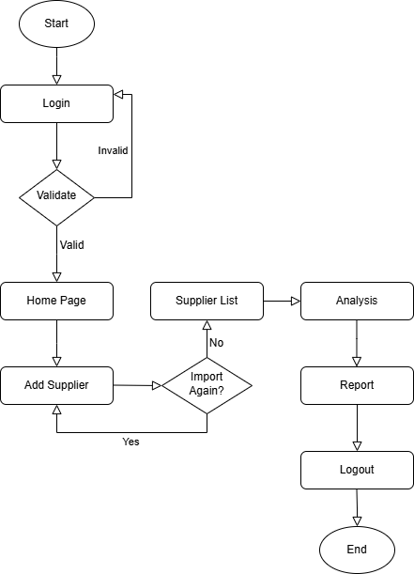

Figure 4.1 System Flowchart
In Figure 4.1, the Supplier Management System begins with a Login page where users authenticate themselves. Upon successful Validation, users are directed to the Home Page, which serves as the central hub for navigation. From here, users can access the Supplier List to view and manage supplier data or perform Analysis to gain insights through visual representations of the data.
Users can add new suppliers manually via the Add Supplier page or import data in bulk using a CSV file. The system also includes a Report feature that provides detailed insights and rankings of suppliers based on various metrics.
Once users complete their tasks, they can securely Logout from the system. The flowchart provided outlines this flow, starting from login, navigating through key functionalities, and ending with logout, ensuring a structured and efficient user experience.

  - Dataset Preparation Overview
The dataset for the Supplier Management System consists of the following attributes described in the Table 4.1.
Table 4.1 Dataset Columns
Attribute | Data Type | Description
supplier_name | String | Name of the supplier
product_category | String | Category of the product supplied
product_quality | String | Quality levels: Very Low, Low, Medium, High, High-End
product_rating |  | Supplier rating based on past performance
  Float (0.1 - 10.0)
min_price | Decimal | Minimum price of the product
max_price | Decimal | Maximum price of the product
email | String
  Supplier’s contact email
phone | String | Supplier’s phone number
address | String | Supplier’s business address

Data cleaning for the Supplier Management System involves handling missing values, standardizing formats, and ensuring data consistency. Missing values in critical fields like supplier_name, product_category, product_quality, supplier_rating, min_price, max_price, email, phone, and address are identified and either imputed or flagged for review.
Categorical values such as product_quality are standardized to predefined levels (Very Low, Low, Medium, High, High-End), while numerical fields like supplier_rating (0.1–10.0) and price values are checked for validity, replacing out-of-range values with appropriate defaults (e.g., median or mean).
Emails and phone numbers undergo regex validation to ensure correct formatting, while duplicate records are detected and removed based on supplier name and product category.
For missing supplier ratings, an average rating per product category is assigned, and if min_price or max_price is missing, the category median is used. The cleaned dataset is then stored in PostgreSQL with constraints to prevent future inconsistencies.

  - Algorithm Implementation
The Weighted Scoring Algorithm for the Supplier Management System is based on Min-Max Normalization, ensuring that different attributes—product quality, supplier rating, and price difference—are scaled to a common range and calculate the final ranking score. This prevents any single attribute from disproportionately influencing the results.

    - Why Min-Max Normalization?
Min-Max Normalization is particularly well-suited because it ensures that all attributes—product quality, product rating, and price difference—are scaled within the same range, typically 0 to 1. This makes comparisons between different attributes fair and prevents any single feature from dominating the ranking process. Without normalization, the price difference (which may be in the hundreds or thousands) would overpower product rating and quality, leading to biased rankings. Min-Max normalization brings all values into a comparable range, ensuring a balanced scoring system.
Min-Max normalization preserves the relative distribution of the data. If a supplier’s product rating is twice as good as another, this relationship remains intact after normalization. Unlike other methods (e.g., Z-score normalization), Min-Max does not distort the meaning of extreme values, which is useful for ranking suppliers effectively.
The weighted scoring algorithm assigns different importance levels to each factor. Since Min-Max scales everything between 0 and 1, it becomes easier to apply meaningful weights (W₁, W₂, W₃) without needing additional transformations. This ensures a smooth combination of product quality, product rating, and price difference when calculating the final supplier score.
Since supplier data is updated through manual entries and CSV imports, Min-Max normalization is efficient and adaptable. Unlike Z-score normalization (which requires recalculating mean and standard deviation), Min-Max only requires tracking min and max values, making it computationally faster for a real-time system.

    - Applying Min-Max Normalization in the Weighted Scoring Algorithm
First, product quality is converted from categorical values (Very Low, Low, Medium, High, High-End) into numerical equivalents (e.g., 1 to 5) to enable mathematical operations. The product rating, which ranges from 0.1 to 10.0, is directly normalized using Min-Max scaling to bring it within 0 to 1.
The price difference is obtained by using the difference between the maximum and minimum price for each supplier. And it is normalized by extracting the minimum and maximum price differences from the dataset to use them as the “Min” and “Max” in the Min-Max Normalization formula.
Once all values are normalized, a Weighted Scoring Algorithm is applied. The final score is computed using a weighted sum of normalized attributes. The formula incorporates weights (W₁, W₂, W₃​) assigned based on the importance of each factor. Product quality and product rating contribute positively to the score, while price difference is subtracted to prioritize suppliers with lower price variations. This ensures that suppliers with better quality, higher ratings, and lower price range rank higher.
By implementing this algorithm in Java Spring Boot, supplier rankings are dynamically calculated whenever new data is added. This scoring system enables better decision-making when selecting suppliers, as it objectively evaluates their performance based on multiple factors. The final rankings can then be displayed on the Ranking Page to help businesses make informed choices.

  - System User Interface (UI)

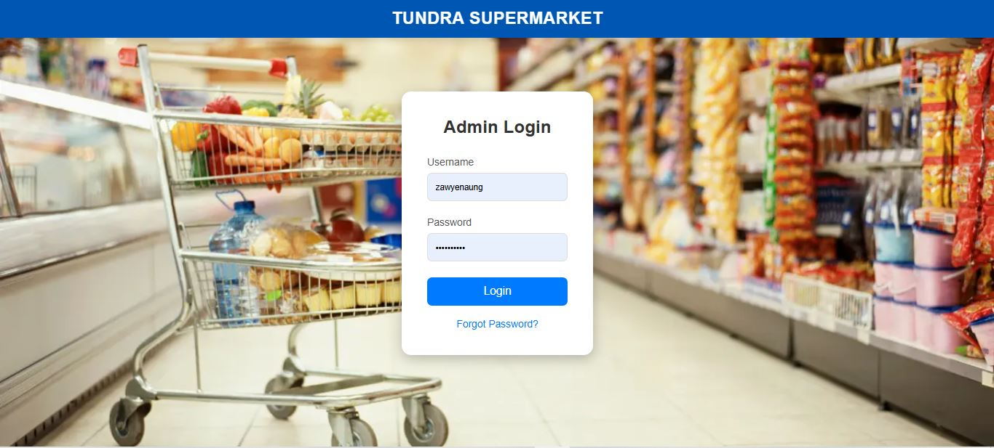
Figure 4.2 Login Page

In Figure 4.2, Login Page validates the username and password to get access to the Supplier Management System platform.

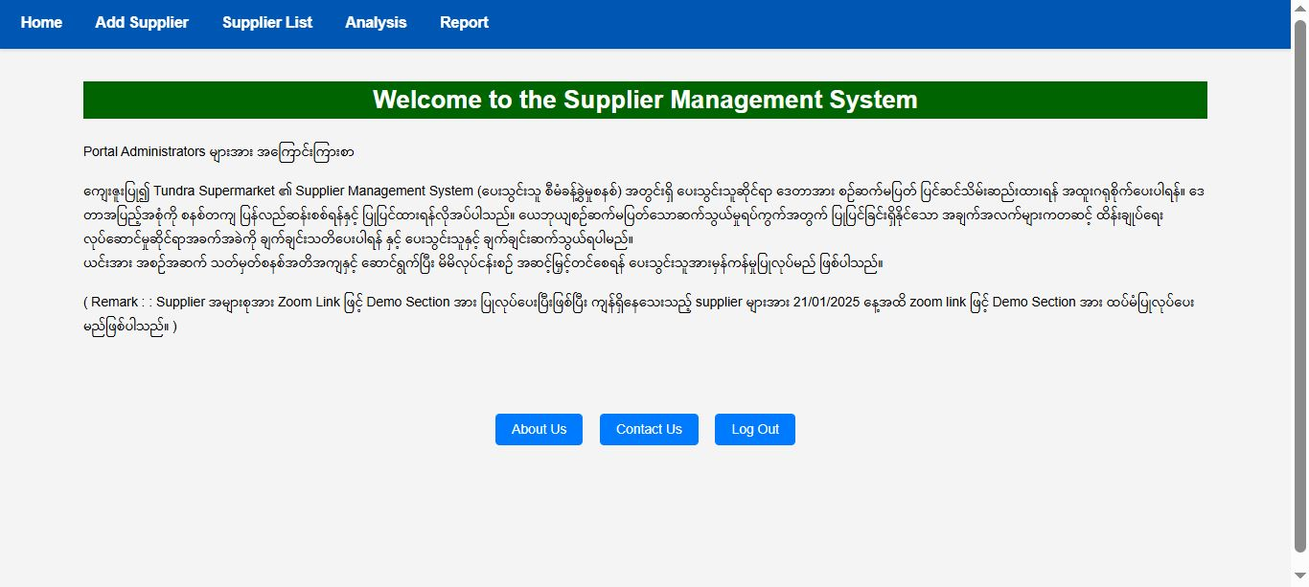
Figure 4.3 Home Page

In Figure 4.3, Home Page users can see some information about the Supplier Management System platform.

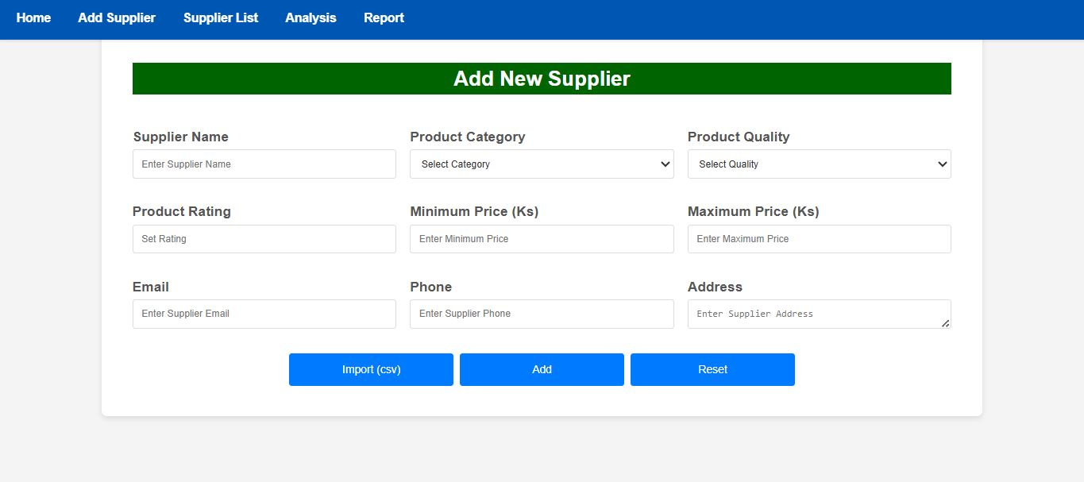
Figure 4.4 Add Supplier Page

In Figure 4.4, users can import the supplier data via CSV dataset or create the suppliers one by one manually in the form.

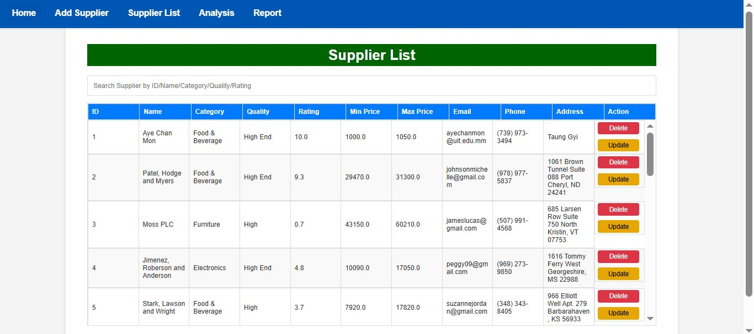

Figure 4.5 Supplier List Page

In Figure 4.5, users can search, read, delete and update the supplier data.

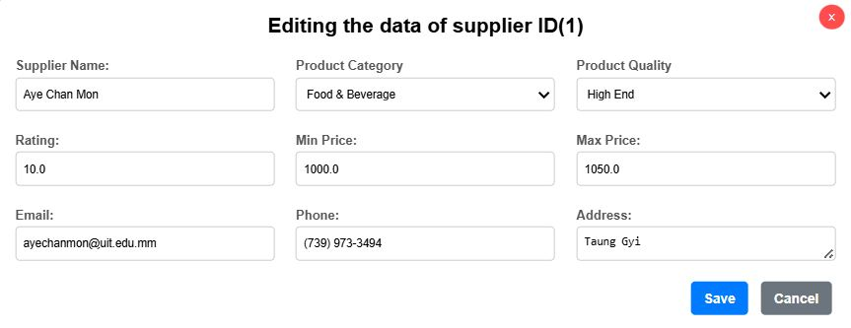
Figure 4.6 Popup Update Form

In Figure 4.6, the supplier data update popup form appear when the user clicked the ‘update’ button on a particular supplier in the Supplier List page.

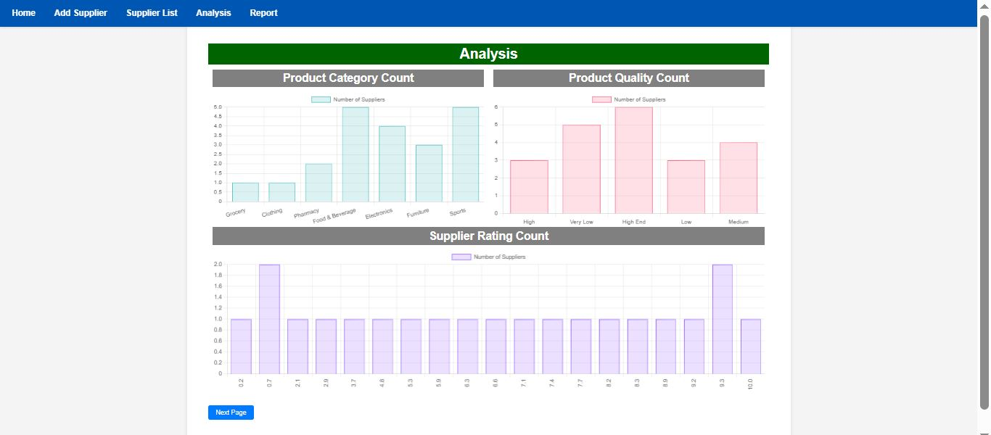

Figure 4.7 Analysis Page 1

In Figure 4.7, users can see the bar charts analysis of the supplier data.

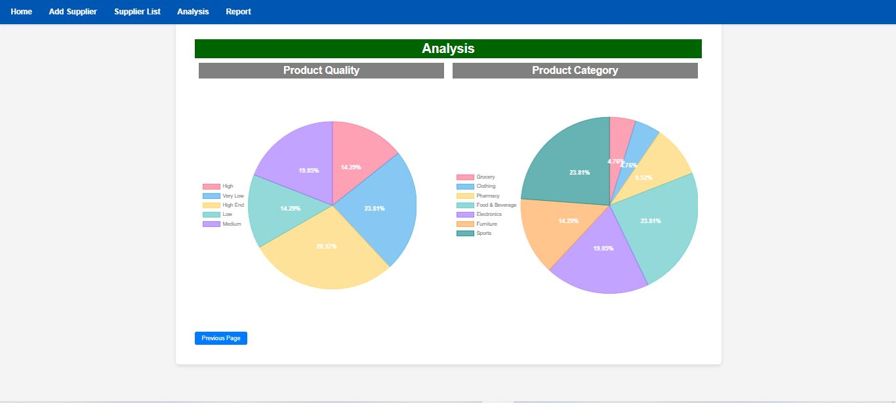
Figure 4.8 Analysis Page 2

In Figure 4.8, users can see the pie charts analysis of the supplier data.

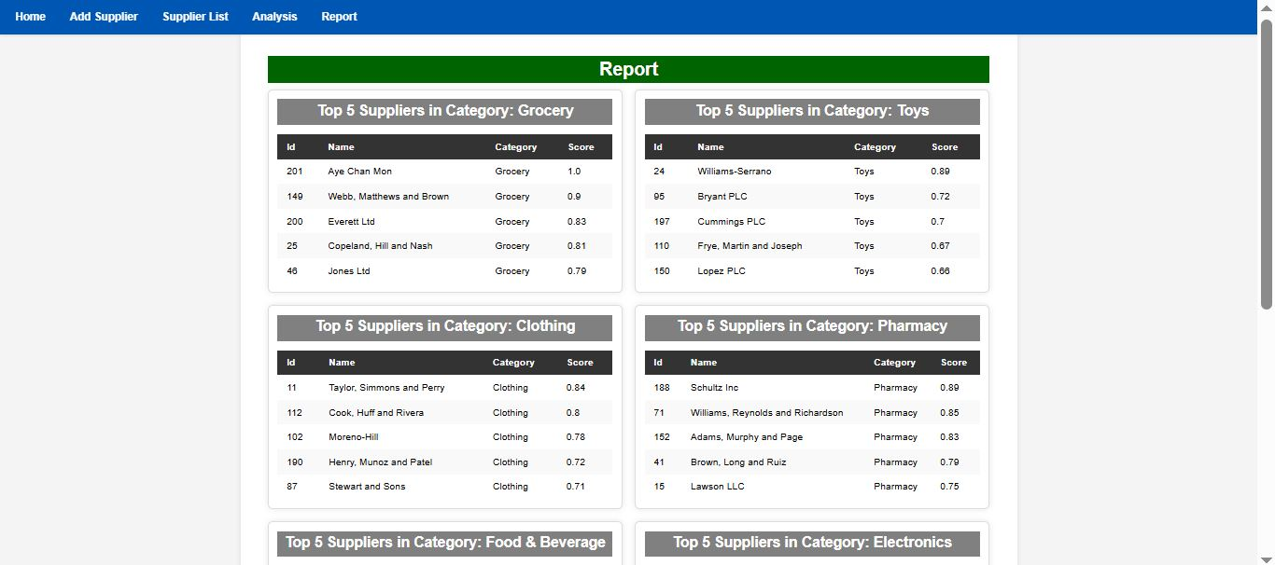

Figure 4.9 Report Page

In Figure 4.9, top and bottom ten suppliers from the system are displayed for performance analysis and further decision making.

CHAPTER 5
TESTING

5.1. Test Case Specifications
    - Supplier Submission Form Page Test

Test Case ID | Test Scenario | Test Steps | Expected Result | Status
TC-01 | Submit a valid supplier entry | Fill in all fields correctly and submit | Supplier record is saved successfully | Pass/Fail
TC-02 | Submit form with missing required fields | Leave one or more mandatory fields empty | System displays an error message | Pass/Fail
TC-03 | Validate email format | Enter an invalid email (e.g., abc@com) | System rejects invalid email | Pass/Fail
TC-04 | Validate phone number format | Enter an invalid phone number (e.g., letters instead of digits) | System rejects invalid phone format | Pass/Fail
TC-05 | Duplicate Supplier Entry | Enter a supplier with the same email or phone number | System prevents duplicate entries | Pass/Fail
TC-06 | Upload valid CSV file | Import a correctly formatted CSV file | Data is imported and displayed in the supplier list | Pass/Fail
TC-07 | Upload CSV with missing fields | Import a CSV file with missing required fields | System rejects the file and shows an error | Pass/Fail
TC-08 | Upload CSV with invalid data | Import a CSV file with incorrect email/phone formats | System rejects invalid records | Pass/Fail

    - Supplier List Page Test

Test Case ID | Test Scenario | Test Steps | Expected Result | Status
TC-09 | Load supplier list | Open the supplier list page | All suppliers are displayed correctly | Pass/Fail
TC-10 | Search for a supplier | Enter a supplier name or category in the search bar | Matching suppliers are displayed | Pass/Fail
TC-11 | Delete a supplier | Click the ‘Delete’ button | Check the supplier correctly deleted in the database | Pass/Fail
TC-12 | Update a supplier’s data | Click the ‘Update’ button and edit the data | Check if the updated data is correct, in the supplier list table | Pass/Fail

    - Analysis Page Test (Bar Charts & Pie Charts)

Test Case ID | Test Scenario | Test Steps | Expected Result | Status
TC-13 | Display bar chart for supplier rating | Navigate to the analysis page 1 | Bar charts with supplier data are displayed correctly | Pass/Fail
TC-14 | Display pie chart for product quality distribution | Navigate to the analysis page 2 | Pie charts with supplier data are correctly visible | Pass/Fail

    - Report Page Test (Weighted Scoring Algorithm)

Test Case ID | Test Scenario | Test Steps | Expected Result | Status
TC-15 | Correct calculation of normalized values | Submit suppliers with varying ratings and prices | Normalized values are correctly computed | Pass/Fail
TC-16 | Correct ranking order | View the ranking page |  | Pass/Fail
  Suppliers are ranked based on the weighted scoring algorithm
TC-17 | Supplier score updates after new entry | Add a new supplier with a high rating | The ranking updates dynamically | Pass/Fail
CHAPTER 6
APPLICATION CONFIGURATION

  - Hardware Requirements
    - Development Environment Requirements
Table 6.1. Environment Requirement for the system
Component | Minimum Requirement | Recommended Requirement
Processor (CPU) | Intel Core i5 (10th Gen) / AMD Ryzen 5 | Intel Core i7 (12th Gen) / AMD Ryzen 7
RAM | 8 GB | 16 GB or higher
Storage (SSD/HDD) | 256 GB SSD or 500 GB HDD | 512 GB SSD or higher
Operating System | Windows 10/11, macOS, Linux (Ubuntu, CentOS) | Latest Windows/macOS/Linux
Network | Broadband internet connection | High-speed fiber internet

    - Server Deployment Requirements
Table 6.2. Server Deployment Requirement
Component | Minimum Requirement | Recommended Requirement
Server Type | Virtual Private Server (VPS) / Cloud Instance | Dedicated Server / High-Performance Cloud Instance
Processor (CPU) | 4 vCPUs (2.4 GHz or higher) | 8+ vCPUs (3.0 GHz or higher)
RAM | 8 GB | 250 GB SSD or higher
Storage (SSD/HDD) | 100 GB SSD | 250 GB SSD or higher
Database Server | PostgreSQL 13+ | PostgreSQL 15+ with replication support
Operating System | Ubuntu 20.04 LTS / Windows Server 2019 | Ubuntu 22.04 LTS / Latest Windows Server
Network Bandwidth | 1 Gbps | 10 Gbps for high traffic

    - Additional Hardware Requirements
- Backup Storage: At least 500 GB external storage or cloud backup for database and application logs.
- UPS (Uninterruptible Power Supply): Ensures uptime in case of power failures.
- Firewall & Security Appliance: Protects against cyber threats if hosting on-premises.
For development, a mid-range laptop or PC with 8-16GB RAM and an SSD is sufficient.
For deployment, a cloud or dedicated server with 8 vCPUs, 16GB RAM, and SSD storage ensures optimal performance, reliability, and scalability.

  - Software Requirements
    - Development Environment Requirements
Table 6.3 Development Environment Requirements
Software Component | Minimum Version | Recommended Version | Purpose
Java Development Kit (JDK) | JDK 11 | JDK 17+ | Required for Java Spring Boot
Spring Boot Framework | 2.5+ | 3.x (latest) | Backend framework for business logic
PostgreSQL Database | 13+ | 15+ | Relational database for storing supplier data
IDE (Eclipse/IntelliJ/VS Code) | Latest | IntelliJ IDEA (Ultimate) | Development and debugging
Maven or Gradle | Latest | Latest | Dependency management
Postman or Curl | Latest | Latest | API testing

    - Server Deployment Requirements
Table 6.4 Server Deployment Requirement
Software Component | Minimum Version | Recommended Version | Purpose
Operating System | Ubuntu 20.04 LTS / Windows Server 2019 | Ubuntu 22.04 LTS / Windows Server 2022 | OS for running the application
Java Runtime Environment (JRE) | JRE 11+ | JRE 17+ | Runs Java applications
Spring Boot Server | Embedded (Tomcat) | Embedded (Tomcat) | Runs the Java backend
PostgreSQL Database Server | 13+ | 15+ | Production database
Nginx or Apache | Latest | Latest | Reverse proxy for load balancing
Docker & Kubernetes | Latest | Latest | Containerized deployment
SSL Certificate | Free (Let's Encrypt) | Commercial (Cloudflare, DigiCert) | Secure HTTPS connection

CHAPTER 7
CONCLUSION

  - Conclusion
The Supplier Management System is designed to enhance the efficiency and effectiveness of managing supplier data. Its primary purpose is to provide businesses with a comprehensive tool for evaluating suppliers based on key criteria such as product quality, product rating, and price ranges. By leveraging a weighted scoring algorithm that normalizes these attributes, the system ensures objective and consistent supplier rankings, helping organizations make informed and data-driven decisions when selecting suppliers. The ability to import data via CSV or manually through forms adds flexibility to the system, accommodating different data entry scenarios. Moreover, the analysis page with bar charts and pie charts allows users to visually assess supplier performance trends, making it easier to identify patterns and outliers. This system is not just about storing supplier data but about turning that data into actionable insights, improving procurement processes, and fostering stronger supplier relationships. Ultimately, the system helps organizations optimize supplier selection and maintain a competitive edge in their supply chain management.

  - Limitation
While the Supplier Management System offers a comprehensive approach to managing and evaluating suppliers, it does have certain limitations:
- Data Quality Dependency: The accuracy and reliability of the supplier rankings heavily depend on the quality of the input data. Inaccurate or incomplete data, such as missing supplier ratings or incorrect price information, can skew the rankings and decision-making process.
- Manual Data Entry Errors: Since the system allows manual entry of supplier data, human error during data input is a potential risk, leading to inconsistencies or data integrity issues.
- Limited Supplier Attributes: The system primarily focuses on a few key supplier attributes like product quality, supplier rating, and price. However, there are many other factors (e.g., delivery time, after-sales service, compliance) that can be important for evaluating suppliers, which are not currently accounted for.
- Scalability Challenges: As the number of suppliers grows significantly, performance may degrade, especially in terms of generating rankings and visual analytics. Additional optimization and scaling efforts may be required for large datasets.
- Lack of Real-Time Updates: The system does not support real-time data updates or integration with external systems (such as ERP or supplier portals), meaning any changes in supplier details require manual intervention or periodic CSV imports.
- Limited Support for Complex Pricing Models: The system assumes a simple minimum price and maximum price for calculating price differences. It may not be suitable for suppliers offering dynamic or complex pricing models based on contracts, discounts, or bulk orders.
- User Access Control: The system currently does not include advanced user role management or access control features, limiting its ability to restrict certain actions (like data edits or access to sensitive information) for specific users.
- Visualization Limitations: While the system supports bar charts and pie charts, it lacks advanced data visualization options like heatmaps, trend analysis, or interactive dashboards that could provide deeper insights into supplier performance.

  - Future Work
While the Supplier Management System offers essential functionalities for managing and evaluating suppliers, there are several opportunities for future enhancements and improvements to make the system more robust, scalable, and user-friendly:
- Integration with Real-Time Data Sources: Future development could integrate real-time data feeds from external systems like supplier portals or ERP platforms, automating data updates and eliminating manual imports.
- Machine Learning for Predictive Ranking: Implementing machine learning algorithms could help the system predict and recommend suppliers based on historical performance and evolving trends, improving supplier selection accuracy.
- Mobile Application Development: A mobile version of the system could be developed to provide users with access to supplier data, rankings, and analytics while on the go, increasing accessibility and flexibility.
- Expanded Evaluation Criteria: The system could incorporate additional supplier evaluation factors like on-time delivery, sustainability practices, and customer support, enabling a more comprehensive and multifaceted supplier ranking system.
- Enhanced Data Visualization: The system could include more advanced interactive dashboards, heatmaps, and trend analysis tools to provide deeper insights into supplier performance, helping businesses make faster and more informed decisions.

LIST OF FIGURES
Figure Page

4.1 System Flow Chart 17

4.2 Login Page 21

4.3 Home Page 21

4.4 Add Supplier Page 22

4.5 Supplier List Page 22

4.6 Popup Update Form 23

4.7 Analysis Page 1 23

4.8 Analysis Page 2 24

4.9 Report Page 24

LIST OF TABLES
Table Page

3.1 Project Charter 14

3.2 Project Schedule 14

4.1 Dataset Columns 18

5.1 Supplier Submission Form Page Test 25

5.2 Supplier List Page Test 26

5.3 Analysis Page Test 26

5.4 Report Page Test 27

6.1 Development Environment Requirements 28

6.2 Server Deployment Requirements 28

6.3 Development Environment Requirements 29

6.4 Server Deployment Requirements 30

REFERENCES

[1] “Multi-Criteria Decision-Making”, https://www.sciencedirect.com/topics/engineering/multi-criteria-decision-making

GitHub Repository:
https://github.com/Tandra18/SMS.git
The official repository of my project with all of the source codes that I have developed.

